Moore FSM Diagram
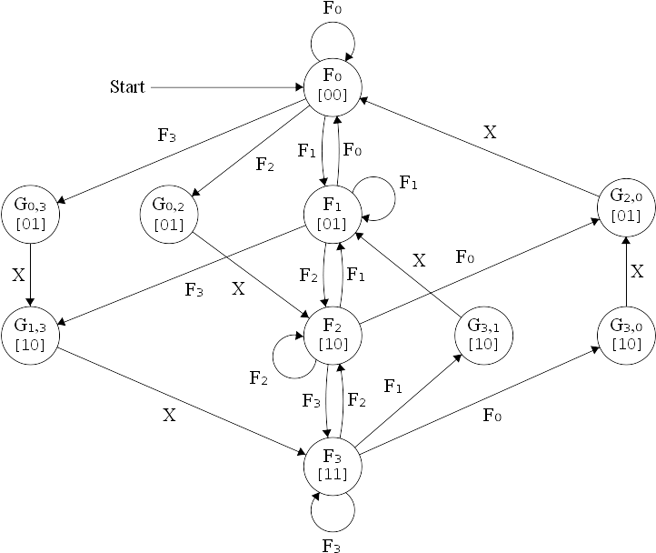
States
F₀ = 0000
F₁ = 0001
F₂ = 0010
F₃ = 0011
G_{0,2} = 0101
G_{1,3} = 0110
G_{2,0} = 1001
G_{3,1} = 1010
G_{0,3} = 1101
G_{3,0} = 1110
State Transition Table
Current State |  |  |  |  | Input |  | Next State |  |  |  |  | Output
Q₃ | Q₂ | Q₁ | Q₀ |  | B | A | Q₃⁺ | Q₂⁺ | Q₁⁺ | Q₀⁺ |  | Q₁ | Q₀
0 | 0 | 0 | 0 |  | 0 | 0 | 0 | 0 | 0 | 0 |  | 0 | 0
 |  |  |  |  | 0 | 1 | 0 | 0 | 0 | 1 |  | 0 | 0
 |  |  |  |  | 1 | 0 | 0 | 1 | 0 | 1 |  | 0 | 0
 |  |  |  |  | 1 | 1 | 1 | 1 | 0 | 1 |  | 0 | 0
0 | 0 | 0 | 1 |  | 0 | 0 | 0 | 0 | 0 | 0 |  | 0 | 1
 |  |  |  |  | 0 | 1 | 0 | 0 | 0 | 1 |  | 0 | 1
 |  |  |  |  | 1 | 0 | 0 | 0 | 1 | 0 |  | 0 | 1
 |  |  |  |  | 1 | 1 | 0 | 1 | 1 | 0 |  | 0 | 1
0 | 0 | 1 | 0 |  | 0 | 0 | 1 | 0 | 0 | 1 |  | 1 | 0
 |  |  |  |  | 0 | 1 | 0 | 0 | 0 | 1 |  | 1 | 0
 |  |  |  |  | 1 | 0 | 0 | 0 | 1 | 0 |  | 1 | 0
 |  |  |  |  | 1 | 1 | 0 | 0 | 1 | 1 |  | 1 | 0
0 | 0 | 1 | 1 |  | 0 | 0 | 1 | 1 | 1 | 0 |  | 1 | 1
 |  |  |  |  | 0 | 1 | 1 | 0 | 1 | 0 |  | 1 | 1
 |  |  |  |  | 1 | 0 | 0 | 0 | 1 | 0 |  | 1 | 1
 |  |  |  |  | 1 | 1 | 0 | 0 | 1 | 1 |  | 1 | 1
0 | 1 | 0 | 1 |  | X | X | 0 | 0 | 1 | 0 |  | 0 | 1
0 | 1 | 1 | 0 |  | X | X | 0 | 0 | 1 | 1 |  | 1 | 0
1 | 0 | 0 | 1 |  | X | X | 0 | 0 | 0 | 0 |  | 0 | 1
1 | 0 | 1 | 0 |  | X | X | 0 | 0 | 0 | 1 |  | 1 | 0
1 | 1 | 0 | 1 |  | X | X | 0 | 1 | 1 | 0 |  | 0 | 1
1 | 1 | 1 | 0 |  | X | X | 1 | 0 | 0 | 1 |  | 1 | 0

Espresso Simplification
Input  #Elevator  .i 6  .o 4  Q In Q⁺  3210 BA 3210  0000 00 0000  0000 01 0001  0000 10 0101  0000 11 1101  0001 00 0000  0001 01 0001  0001 10 0010  0001 11 0110  0010 00 1001  0010 01 0001  0010 10 0010  0010 11 0011  0011 00 1110  0011 01 1010  0011 10 0010  0011 11 0011  0101 -- 0010  0110 -- 0011  1001 -- 0000  1010 -- 0001  1101 -- 0110  1110 -- 1001 | Output  #Elevator  .i 6  .o 4  .p 16  Q In D  3210 BA 3210  0011 00 0100  000- 11 0100  0000 11 1000  0010 00 1001 *  1101 -- 0100  000- 01 0001  1110 -- 1000  001- 11 0001  0011 0- 1010 *  0000 1- 0101 *  00-1 1- 0010  -101 -- 0010  0-10 1- 0010  1-10 -- 0001  0110 -- 0011 *  --10 -1 0001  .e
Boolean Equations
D₃ = Q₃·Q₂·Q₁·Q₀·B·A + Q₃·Q₂·Q₁·Q₀·B·A + Q₃·Q₂·Q₁·Q₀ + Q₃·Q₂·Q₁·Q₀·B
D₂ = Q₃·Q₂·Q₁·Q₀·B·A + Q₃·Q₂·Q₁·B·A + Q₃·Q₂·Q₁·Q₀ + Q₃·Q₂·Q₁·Q₀·B
D₁ = Q₃·Q₂·Q₁·Q₀·B + Q₃·Q₂·Q₀·B + Q₂·Q₁·Q₀ + Q₃·Q₁·Q₀·B + Q₃·Q₂·Q₁·Q₀
D₀ = Q₃·Q₂·Q₁·Q₀·B·A + Q₃·Q₂·Q₁·B·A + Q₃·Q₂·Q₁·B·A + Q₃·Q₂·Q₁·Q₀·B + Q₃·Q₁·Q₀ + Q₃·Q₂·Q₁·Q₀ + Q₁·Q₀·A
 | 16 NOR Gates  3 – 3 input NOR gates  5 – 4 input NOR gates  5 – 5 input NOR gates  3 – 6 input NOR gates | 4 OR Gates  2 – 4 input OR gates  1 – 5 input OR gate  1 – 7 input OR gate
 | 32 Inverters
 | 4 D-Flip-Flops
 | 2 D-Latches
 | 1 – 2-Select Bits Priority Encoder
 | 1 – 2-Select Bits Decoder
 | ~428 MOSFETs Total
Logisim Digital Circuit
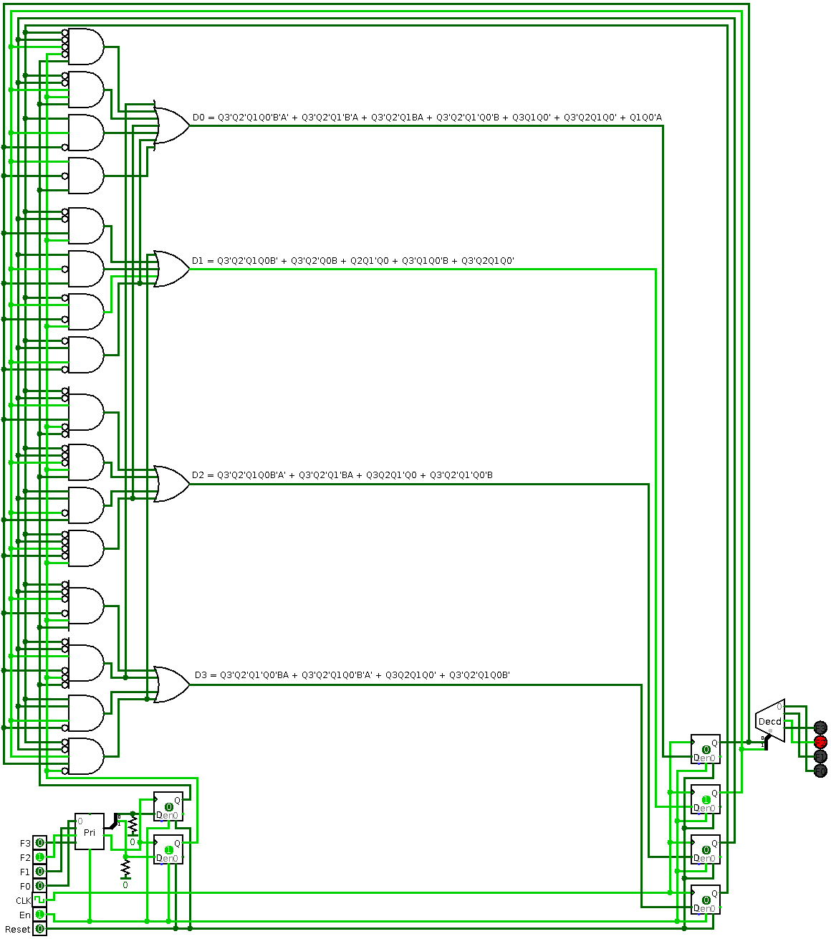
Python MyHDL Code
from myhdl import always, always_comb, always_seq, Signal, ResetSignal, toVerilog, toVHDL, delay, traceSignals, Simulation, now, intbv, concat

#Implementation

def elevator(clk, reset, en, F, D, Q, A, B, A_latch, B_latch, LED):

@always_comb
def encoder():
if bool(F) and en:
A.next = bool(F[3] or (F[1] and not F[2]))
B.next = bool(F[2] or F[3])

@always_comb
def latch():
if reset:
A_latch.next = bool(False)
B_latch.next = bool(False)
elif bool(F) and en:
A_latch.next = A
B_latch.next = B

@always_comb
def logic():
D.next = concat( bool((not Q[3] and not Q[2] and not Q[1] and not Q[0] and B_latch and A_latch) or (not Q[3] and not Q[2] and Q[1] and not Q[0] and not B_latch and not A_latch) or (Q[3] and Q[2] and Q[1] and not Q[0]) or (not Q[3] and not Q[2] and Q[1] and Q[0] and not B_latch)),
bool((not Q[3] and not Q[2] and Q[1] and Q[0] and not B_latch and not A_latch) or (not Q[3] and not Q[2] and not Q[1] and B_latch and A_latch) or (Q[3] and Q[2] and not Q[1] and Q[0]) or (not Q[3] and not Q[2] and not Q[1] and not Q[0] and B_latch)),
bool((not Q[3] and not Q[2] and Q[1] and Q[0] and not B_latch) or (not Q[3] and not Q[2] and Q[0] and B_latch) or (Q[2] and not Q[1] and Q[0]) or (not Q[3] and Q[1] and not Q[0] and B_latch) or (not Q[3] and Q[2] and Q[1] and not Q[0])),
bool((not Q[3] and not Q[2] and Q[1] and not Q[0] and not B_latch and not A_latch) or (not Q[3] and not Q[2] and not Q[1] and not B_latch and A_latch) or (not Q[3] and not Q[2] and Q[1] and B_latch and A_latch) or (not Q[3] and not Q[2] and not Q[1] and not Q[0] and B_latch) or (Q[3] and Q[1] and not Q[0]) or (not Q[3] and Q[2] and Q[1] and not Q[0]) or (Q[1] and not Q[0] and A_latch)) )

@always_seq(clk.posedge, reset)
def dff():
if en:
Q.next = D

@always_comb
def decoder():
LED.next = concat( bool(Q[1] and Q[0]),
bool(Q[1] and not Q[0]),
bool(not Q[1] and Q[0]),
bool(not Q[1] and not Q[0]) )

return encoder, latch, logic, dff, decoder
Python MyHDL Verilog and VHDL Conversion Code
#Convert to Verilog

def convert():
clk = Signal(bool(False))
reset = ResetSignal(bool(False), bool(True), async=True)
en = Signal(bool(True))
F = Signal(intbv(0b0, 0b0, 0b10000))
D = Signal(intbv(0b0, 0b0, 0b10000))
Q = Signal(intbv(0b0, 0b0, 0b10000))
A = Signal(bool(False))
B = Signal(bool(False))
A_latch = Signal(bool(False))
B_latch = Signal(bool(False))
LED = Signal(intbv(0b0, 0b0, 0b10000))
toVerilog.timescale = "100ms/1ms"
toVerilog(elevator, clk, reset, en, F, D, Q, A, B, A_latch, B_latch, LED)
toVHDL(elevator, clk, reset, en, F, D, Q, A, B, A_latch, B_latch, LED)

convert()
Python MyHDL Simulation Code
#Simulate

def test_elevator():
clk = Signal(bool(False))
reset = ResetSignal(bool(False), bool(True), async=True)
en = Signal(bool(True))
F = Signal(intbv(0b0, 0b0, 0b10000))
D = Signal(intbv(0b0, 0b0, 0b10000))
Q = Signal(intbv(0b0, 0b0, 0b10000))
A = Signal(bool(False))
B = Signal(bool(False))
A_latch = Signal(bool(False))
B_latch = Signal(bool(False))
LED = Signal(intbv(0b0, 0b0, 0b10000))
elevator_inst = elevator(clk, reset, en, F, D, Q, A, B, A_latch, B_latch, LED)

@always(delay(10))
def clkgen():
clk.next = not clk

@always(delay(1))
def stimulus():
if now() == 45:
F.next = Signal(intbv(0b0100))
elif now() == 46:
F.next = Signal(intbv(0b0000))
elif now() == 60:
F.next = Signal(intbv(0b0001))
elif now() == 61:
F.next = Signal(intbv(0b0000))
elif now() == 150:
F.next = Signal(intbv(0b0010))
elif now() == 200:
F.next = Signal(intbv(0b0011))
elif now() == 250:
F.next = Signal(intbv(0b0100))
elif now() == 300:
F.next = Signal(intbv(0b0101))
elif now() == 350:
F.next = Signal(intbv(0b0110))
elif now() == 400:
F.next = Signal(intbv(0b0111))
elif now() == 450:
F.next = Signal(intbv(0b1000))
elif now() == 500:
F.next = Signal(intbv(0b1001))
elif now() == 550:
F.next = Signal(intbv(0b1010))
elif now() == 600:
F.next = Signal(intbv(0b1011))
elif now() == 650:
F.next = Signal(intbv(0b1100))
#reset.next = 0b1
elif now() == 700:
F.next = Signal(intbv(0b1101))
elif now() == 750:
F.next = Signal(intbv(0b1110))
elif now() == 800:
F.next = Signal(intbv(0b0001))
elif now() == 850:
F.next = Signal(intbv(0b1000))
#reset.next = 0b0
elif now() == 900:
F.next = Signal(intbv(0b0010))
elif now() == 950:
F.next = Signal(intbv(0b1000))
#en.next = 0b0
elif now() == 1000:
F.next = Signal(intbv(0b0001))
elif now() == 1050:
F.next = Signal(intbv(0b0100))
elif now() == 1100:
F.next = Signal(intbv(0b0001))
elif now() == 1150:
F.next = Signal(intbv(0b0100))
elif now() == 1200:
F.next = Signal(intbv(0b0000))
elif now() == 1240:
F.next = Signal(intbv(0b0000))
#en.next = 0b1
elif now() == 1360:
F.next = Signal(intbv(0b0001))
elif now() == 1370:
F.next = Signal(intbv(0b1001))

return elevator_inst, clkgen, stimulus#, reset_test, en_test

def simulate(timesteps):
traceSignals.timescale = "100ms"
tb = traceSignals(test_elevator)
sim = Simulation(tb)
sim.run(timesteps)

simulate(1500)

Verilog Code
// File: elevator.v
// Generated by MyHDL 0.8.1
// Date: Sun Jun 14 22:11:56 2015

`timescale 100ms/1ms

module elevator (
clk,
reset,
en,
F,
D,
Q,
A,
B,
A_latch,
B_latch,
LED
);

input clk;
input reset;
input en;
input [3:0] F;
output [3:0] D;
wire [3:0] D;
output [3:0] Q;
reg [3:0] Q;
output A;
reg A;
output B;
reg B;
output A_latch;
reg A_latch;
output B_latch;
reg B_latch;
output [3:0] LED;
wire [3:0] LED;

always @(en, F) begin: ELEVATOR_ENCODER
if (((F != 0) && en)) begin
A = ((F[3] || (F[1] && (!F[2]))) != 0);
B = ((F[2] || F[3]) != 0);
end
end

always @(reset, A, B, en, F) begin: ELEVATOR_LATCH
if (reset) begin
A_latch = (1'b0 != 0);
B_latch = (1'b0 != 0);
end
else if (((F != 0) && en)) begin
A_latch = A;
B_latch = B;
end
end

assign D = {((((!Q[3]) && (!Q[2]) && (!Q[1]) && (!Q[0]) && B_latch && A_latch) || ((!Q[3]) && (!Q[2]) && Q[1] && (!Q[0]) && (!B_latch) && (!A_latch)) || (Q[3] && Q[2] && Q[1] && (!Q[0])) || ((!Q[3]) && (!Q[2]) && Q[1] && Q[0] && (!B_latch))) != 0), ((((!Q[3]) && (!Q[2]) && Q[1] && Q[0] && (!B_latch) && (!A_latch)) || ((!Q[3]) && (!Q[2]) && (!Q[1]) && B_latch && A_latch) || (Q[3] && Q[2] && (!Q[1]) && Q[0]) || ((!Q[3]) && (!Q[2]) && (!Q[1]) && (!Q[0]) && B_latch)) != 0), ((((!Q[3]) && (!Q[2]) && Q[1] && Q[0] && (!B_latch)) || ((!Q[3]) && (!Q[2]) && Q[0] && B_latch) || (Q[2] && (!Q[1]) && Q[0]) || ((!Q[3]) && Q[1] && (!Q[0]) && B_latch) || ((!Q[3]) && Q[2] && Q[1] && (!Q[0]))) != 0), ((((!Q[3]) && (!Q[2]) && Q[1] && (!Q[0]) && (!B_latch) && (!A_latch)) || ((!Q[3]) && (!Q[2]) && (!Q[1]) && (!B_latch) && A_latch) || ((!Q[3]) && (!Q[2]) && Q[1] && B_latch && A_latch) || ((!Q[3]) && (!Q[2]) && (!Q[1]) && (!Q[0]) && B_latch) || (Q[3] && Q[1] && (!Q[0])) || ((!Q[3]) && Q[2] && Q[1] && (!Q[0])) || (Q[1] && (!Q[0]) && A_latch)) != 0)};

always @(posedge clk, posedge reset) begin: ELEVATOR_DFF
if (reset == 1) begin
Q <= 0;
end
else begin
if (en) begin
Q <= D;
end
end
end

assign LED = {((Q[1] && Q[0]) != 0), ((Q[1] && (!Q[0])) != 0), (((!Q[1]) && Q[0]) != 0), (((!Q[1]) && (!Q[0])) != 0)};

endmodule

VHDL Code
-- File: elevator.vhd
-- Generated by MyHDL 0.8.1
-- Date: Sun Jun 14 22:11:56 2015

library IEEE;
use IEEE.std_logic_1164.all;
use IEEE.numeric_std.all;
use std.textio.all;

use work.pck_myhdl_081.all;

entity elevator is
port (
clk: in std_logic;
reset: in std_logic;
en: in std_logic;
F: in unsigned(3 downto 0);
D: inout unsigned(3 downto 0);
Q: inout unsigned(3 downto 0);
A: inout std_logic;
B: inout std_logic;
A_latch: inout std_logic;
B_latch: inout std_logic;
LED: out unsigned(3 downto 0)
);
end entity elevator;

architecture MyHDL of elevator is

begin

ELEVATOR_ENCODER: process (en, F) is
begin
if (bool(F) and bool(en)) then
A <= stdl(bool(F(3)) or (bool(F(1)) and (not bool(F(2)))));
B <= stdl(bool(F(2)) or bool(F(3)));
end if;
end process ELEVATOR_ENCODER;

ELEVATOR_LATCH: process (reset, A, B, en, F) is
begin
if bool(reset) then
A_latch <= '0';
B_latch <= '0';
elsif (bool(F) and bool(en)) then
A_latch <= A;
B_latch <= B;
end if;
end process ELEVATOR_LATCH;

D <= unsigned'((((not bool(Q(3))) and (not bool(Q(2))) and (not bool(Q(1))) and (not bool(Q(0))) and bool(B_latch) and bool(A_latch)) or ((not bool(Q(3))) and (not bool(Q(2))) and bool(Q(1)) and (not bool(Q(0))) and (not bool(B_latch)) and (not bool(A_latch))) or (bool(Q(3)) and bool(Q(2)) and bool(Q(1)) and (not bool(Q(0)))) or ((not bool(Q(3))) and (not bool(Q(2))) and bool(Q(1)) and bool(Q(0)) and (not bool(B_latch)))) & (((not bool(Q(3))) and (not bool(Q(2))) and bool(Q(1)) and bool(Q(0)) and (not bool(B_latch)) and (not bool(A_latch))) or ((not bool(Q(3))) and (not bool(Q(2))) and (not bool(Q(1))) and bool(B_latch) and bool(A_latch)) or (bool(Q(3)) and bool(Q(2)) and (not bool(Q(1))) and bool(Q(0))) or ((not bool(Q(3))) and (not bool(Q(2))) and (not bool(Q(1))) and (not bool(Q(0))) and bool(B_latch))) & (((not bool(Q(3))) and (not bool(Q(2))) and bool(Q(1)) and bool(Q(0)) and (not bool(B_latch))) or ((not bool(Q(3))) and (not bool(Q(2))) and bool(Q(0)) and bool(B_latch)) or (bool(Q(2)) and (not bool(Q(1))) and bool(Q(0))) or ((not bool(Q(3))) and bool(Q(1)) and (not bool(Q(0))) and bool(B_latch)) or ((not bool(Q(3))) and bool(Q(2)) and bool(Q(1)) and (not bool(Q(0))))) & (((not bool(Q(3))) and (not bool(Q(2))) and bool(Q(1)) and (not bool(Q(0))) and (not bool(B_latch)) and (not bool(A_latch))) or ((not bool(Q(3))) and (not bool(Q(2))) and (not bool(Q(1))) and (not bool(B_latch)) and bool(A_latch)) or ((not bool(Q(3))) and (not bool(Q(2))) and bool(Q(1)) and bool(B_latch) and bool(A_latch)) or ((not bool(Q(3))) and (not bool(Q(2))) and (not bool(Q(1))) and (not bool(Q(0))) and bool(B_latch)) or (bool(Q(3)) and bool(Q(1)) and (not bool(Q(0)))) or ((not bool(Q(3))) and bool(Q(2)) and bool(Q(1)) and (not bool(Q(0)))) or (bool(Q(1)) and (not bool(Q(0))) and bool(A_latch))));

ELEVATOR_DFF: process (clk, reset) is
begin
if (reset = '1') then
Q <= to_unsigned(0, 4);
elsif rising_edge(clk) then
if bool(en) then
Q <= D;
end if;
end if;
end process ELEVATOR_DFF;

LED <= unsigned'((bool(Q(1)) and bool(Q(0))) & (bool(Q(1)) and (not bool(Q(0)))) & ((not bool(Q(1))) and bool(Q(0))) & ((not bool(Q(1))) and (not bool(Q(0)))));

end architecture MyHDL;

Waveform Viewer
Logic:
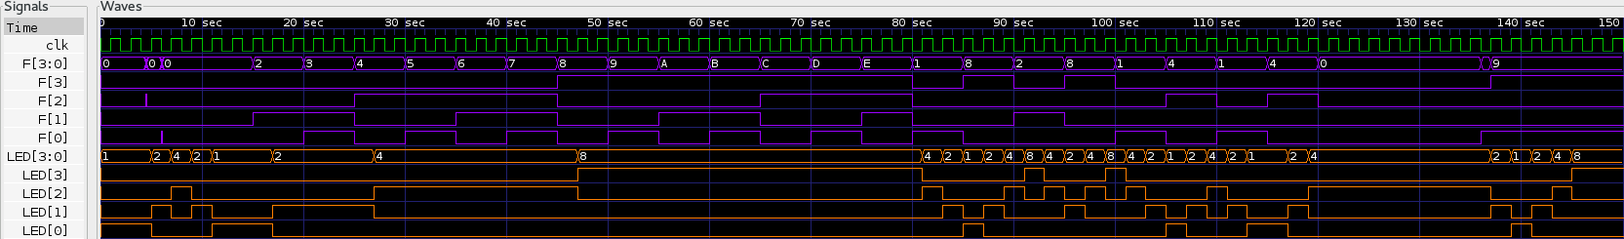
Reset and en:
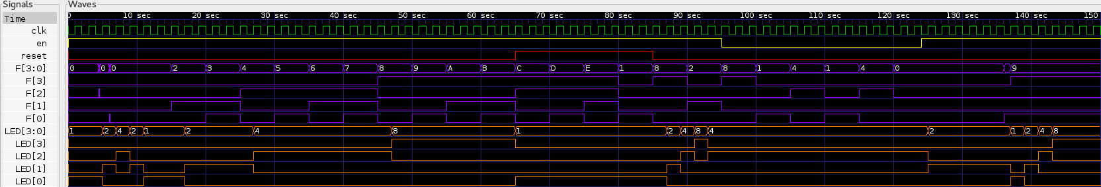

The design can be improved by having the output going back and forth between extremes when multiple buttons are selected simultaneously, optimally by first going to the closest floor. This can be implemented with an additional FSM in place of the priority encoder.

